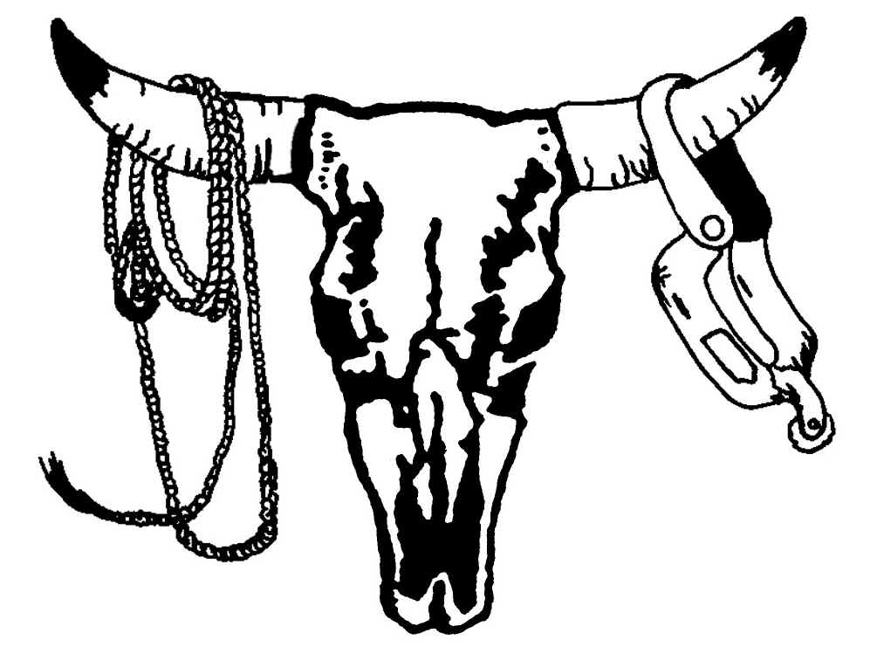
INTERSTATES RODEO ASSOCIATION
118 Washington Street

Grand River, Iowa 50108

Phone/Fax: (641) 773-5232

2026 Application

Print Clearly DATE:___________

Contestant $85 ___________ Timers - $45_______ Personnel - $85 ____________

Circle one: New Old

Name: _________________________________________________ IRA #: _____________________

Address: _______________________________________________ City: _______________________

State: ____________________ Zip: ______________ Phone: ____________________________

Date of Birth: __________________________ Soc. Sec. #: _______________________________

I work the following events: Calf Roping and Over/40: Circle the one for All-Around points
Breakaway and Calf Roping: Circle one for All-Around points
Bareback Saddle Bronc Bull riding Calf Roping Forty & Over CR
Break-Away Barrel Racing Team Roping Steer Wrestling Ranch Broncs
Timer Judge Pick-Up Man Bull Fighter Announcer
Photographer Barrel Man Specialty Act Stock Contractor Producer
Clown Secretary Other__________________________________________________

Applicants under 21
I certify that the age and date of birth of the below named child is correct, and I hereby consent to the participation of my/our child in the Interstates Rodeo Association, Inc. I agree that in no event will I hold the IRA, Inc., its agents, or employees liable for injury or property damage during participation at an IRA sanctioned rodeo or while enroute to or from an IRA sanctioned rodeo.
Applicant: _______________________________________ Birthdate: ________________________
Address: ________________________________________ Age: _____________________________
City: ___________________________________________ Zip: ______________________________
Phone: _____________________________ Soc. Sec. #: ____________________________________
Parent/Guardian Signature: _________________________________ Must be notarized
The foregoing instrument was acknowledged before me this _____________day of ________20_____ by __________________________________ parent or guardian of the above IRA contestant, and I certify that the above information is true to the best of my knowledge.
Notary Public _____________________________ Date ___________ My Commission Expires __________.

The I.R.A. its sponsors, rodeo committees, rodeo production entities, Officers and Directors, employees, and agents of such entities, assume no responsibility or liability for injury or damages to the person, property, or stock of any owner, contestant, or assistant or other claims arising from participation in I.R.A. sanctioned rodeos, including claims that are known and unknown, foreseen and unforeseen, future and contingent.

Signed: _____________________________________________________________ Date:_________________________

